Waste disposal
Waste disposal, the collection, processing, and recycling or deposition of the waste materials of human society. Waste is classified by source and composition. Broadly speaking, waste materials are either liquid or solid in form, and their components may be either hazardous or inert in their effects on health and the environment. The term waste is typically applied to solid waste, sewage (wastewater), hazardous waste, and electronic waste.
In industrialized countries, municipal liquid waste is funneled through sewage systems, where it undergoes wastewater treatment, or sewage treatment. This process removes most or all of the impurities from wastewater, or sewage, before they can reach groundwater aquifers or surface waters such as rivers, lakes, estuaries, and oceans.
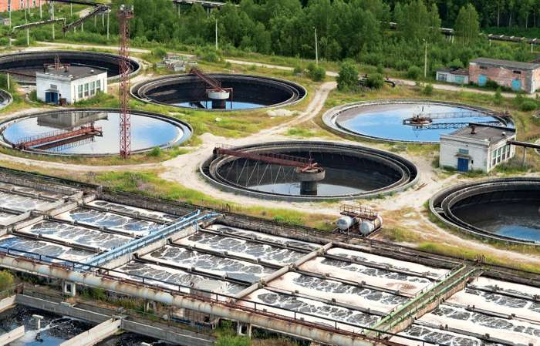
wastewater-treatment plantWastewater-treament plants remove chemical or biological waste from water. © huimin/Fotolia
Refuse, or municipal solid waste (MSW), is nonhazardous solid waste from a community that requires collection and transport to a processing or disposal site. Refuse includes garbage and rubbish. Garbage is mostly decomposable food waste, and rubbish is mostly dry material such as glass, paper, cloth, or wood. Garbage is highly putrescible or decomposable, whereas rubbish is not. Trash is rubbish that includes bulky items such as old refrigerators, couches, large tree stumps, or construction and demolition waste (e.g., wood, drywall, bricks, concrete) all of which often require special collection and handling. Refuse is often deposited in sanitary landfills—that is, pits or other sites sealed with impermeable synthetic bottom liners where waste is isolated from the rest of the environment.
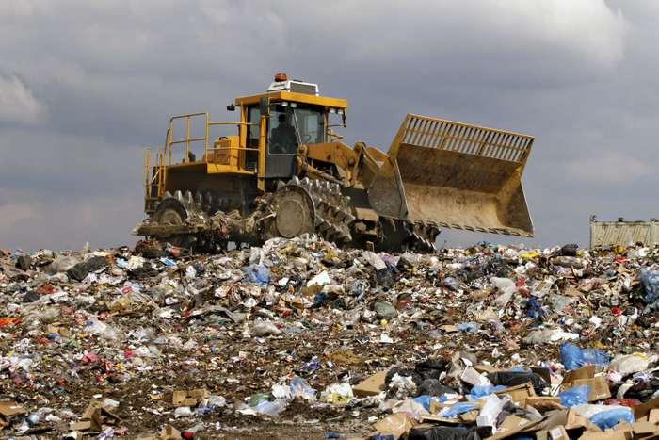
Some forms of solid and liquid waste are classified as hazardous because they are harmful to human health and the environment. Hazardous wastes include materials that are toxic, reactive, ignitable, corrosive, infectious, or radioactive. Toxic waste is essentially chemical waste from industrial, chemical, or biological processes that can cause injury or death when it is either ingested or absorbed by the skin. Reactive wastes are chemically unstable and react violently or explosively with air or water. Infectious wastes (such as used bandages, hypodermic needles, and other materials from medical and research facilities) are materials that may contain pathogens. Radioactive wastes (such as spent fuel rods containing fissionable materials used in nuclear power generation and isotopes of cobalt and iodine used in cancer treatment and other medical applications) emit ionizing energy that can harm living organisms. Hazardous wastes pose special handling, storage, and disposal challenges that vary according the nature of the material.
Electronic waste, or e-waste, is electronic equipment that has ceased to be of value to users or that no longer satisfies its original purpose as a result of either redundancy, replacement, or breakage. Electronic waste includes both “white goods” such as refrigerators, washing machines, and microwave ovens and “brown goods” such as televisions, radios, computers, and cellular telephones. E-waste differs from traditional municipal waste. Although e-waste contains complex combinations of highly toxic substances (such as lead and cadmium in computers and cellular telephones) that pose a danger to health and the environment, which should be treated as hazardous materials with respect to their disposal, it also contains nonrecyclable parts that enter the municipal solid waste stream. Electronic devices also contain recoverable parts made of gold, silver, platinum, and other valuable materials, as well as recyclable materials (such as plastics and copper), that can be used to make new electronic items. 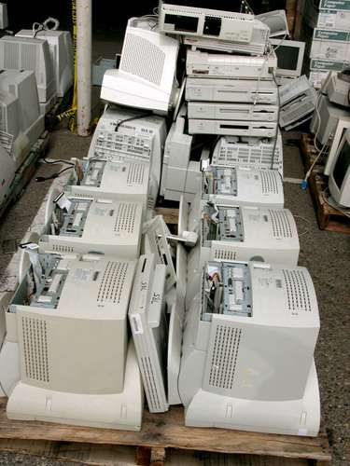
ANSWER THE FOLLOWING QUESTIONS

- What is waste disposal?
- What does the term ’’waste’’ encompass?
- How is it possible to classify waste?
- What is the job of wastewater-treatment plants?
- How would you define refuse?
- Explan the difference between garbage, rubbish and trash.
- What is a sanitary landfill?
- Which materials are treated as hazardous waste?
- Explain the meaning of ’’ingest’’ and ’’absorb by the skin’’.
- Where can pathogens be found?
- Is reactive waste the same as radioactive waste?
- How should hazardous waste be treated?
- Translate part of the text reffering to hazardous waste.
- What is e-waste?
- What are ’’white’’ and ’’brown’’ goods?
- Name some of the toxic substances found in e-waste.
- Is it possible to recycle e-waste?

Guess the words behind the definitions

1.waste that has substantial or potential threats to public health or the environment______________

2.capable of being partitioned, like when organic substances are broken down into simpler forms of matter _____________________
3.a type of wastewater that is produced by a community of people ___________________
4.capable of catching or being set on fire_______________
Translate these terms into Serbian
remove impurities from wastewater-
groundwater aquifier-
wastewater treatment-
disposal site-
impermeable-
Define these terms in English
pit-
solid waste-
liquid waste-

